# **Template –****Custom Content with Video**

The template named “Template – Custom Content with Video” is applicable to CampusNexus Student.

## Purpose and Outcome

This template provides an anonymous form sequence and supporting workflow for the use of a video in a form. Videos can be used to give a campus tour or instructions for filling out complicated Financial Aid forms or anything similar.

## Prerequisites

The template was built with Forms Builder using the applications listed below. The template is forward compatible with later versions of the listed applications.

|  |  |
| --- | --- |
| **Application** | **Minimum Version** |
| Forms Builder Designer and Renderer | 3.7 |
| Web Client for CampusNexus Student | 21.1 |
| Workflow Composer | 3.0.x |
| Packages installed from Package Manager in Workflow Composer | Activities and Contracts (V1) 21.1.0  Activities and Contracts (V2) 21.1.0  Forms Builder Contracts 3.6.x |
| Workflow Tracking Database | N/A |
| Staff STS 2.1 | 2.1 |

## Step 1: Download and Import the Template

1. Download the template file to your environment (local drive or network location).
2. Log into **Forms Builder** and select the **Export/Import** tile.
3. Select the **Import** tab.
4. Click **Select exported file** and navigate to the downloaded template file (xml).
5. Click **Import**.

* [Export/Import](https://help.campusmanagement.com/FB/3.x/Content/ExportImport.htm)

### The “Video Example” and “Default-Confirmation” forms will be imported.

## Step 2: Upload a Video File

1. Select the **Custom Content** tile in Forms Builder.
2. Click **Select custom content files** and navigate to your video file (mp4) or drag and drop the mp4 file into the workspace. Once the file is uploaded, it will be listed in the grid.

* [Custom Content](https://help.campusmanagement.com/fb/3.x/Content/CustomContent.htm)

## Step 3: In Form Designer…

1. From the **Forms** slide out, select the **Video Example** form.
2. Customize the form for your environment. Modify properties on fields/components to make them required, etc., or add/remove fields on the form.

* [Fields](https://help.campusmanagement.com/FB/3.x/Content/Fields.htm) and [Components](https://help.campusmanagement.com/FB/3.x/Content/Components.htm)

The form example has two HTML components. Edit the instructional text in the first component. Specify the file name of your video in the second component.

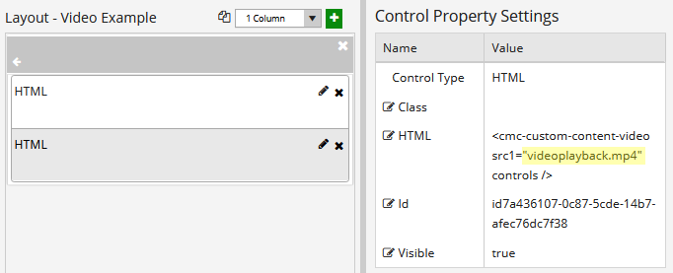

1. **Save** the form.

## Step 4: In Sequence Designer…

1. Locate the **Video Example** sequence in the Sequences pane.
2. Click **Save As** to create a copy of the sequence/workflow and customize the copy for your use. This way you can always refer to the original sequence/workflow you downloaded.
3. (Optional) Customize the sequence properties for your environment.
4. (Optional) Add a custom style (theme) for your campus.

* [Themes](https://help.campusmanagement.com/FB/3.x/Content/Themes.htm)

1. Select your saved sequence in the Sequences pane.
2. In the Properties Pane, as **End State Form**, select the imported “Default-Confirmation”.
3. **Save** the sequence**.**

## Step 5: In Workflow Composer…

You do not need to modify anything in the workflow.

1. (Optional) Open the workflow for your saved sequence.

* [Opening Workflows for Sequences](https://help.campusmanagement.com/FB/3.x/Content/HostedEnv.htm)

1. (Optional) Explore the workflow to get an understanding of the workflow logic.

* [State Machine Workflows](https://help.campusmanagement.com/FB/3.x/Content/StateMachineWorkflows.htm)

## Step 6: In Forms Renderer…

Select your sequence and try it out!

* [Sequence List](https://help.campusmanagement.com/FB/3.x/Content/SequenceList.htm)

1. Find your sequenceand copy the **URL** to the clipboard.
2. Paste the URL into a browser and complete the form sequence.

## Step 6: Lastly…

Once your updated sequence has been tested successfully, it is recommended that you disable the workflow for the original Template version.

1. In Workflow Composer, in the Server section of the ribbon, click **Open**.
2. Find the workflow named **Video Example**.
3. Clear the **Enabled** check box and click **Save**.